Booster damper logbook part 2
progress notes by Bill Ashmanskas
2008-07-11
Today's goal is to make the horizontal coordinate damp.
graph26: coarse timing, horizontal damper.

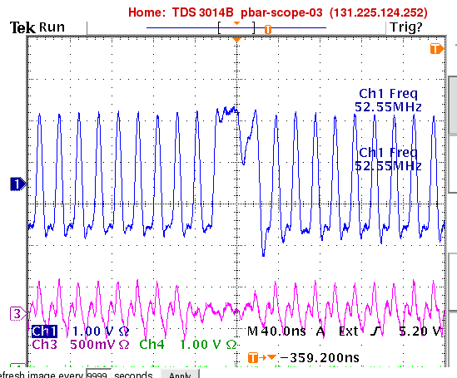

graph28: horizontal damping. This doesn't look nearly as impressive as vertical damping. The damper struggles to excite the beam, doesn't excite a very large oscillation, and then damps it. The damping time is faster than the decoherence time, but the decoherence time is far faster than in the vertical plane. On the top plot, red is damper on, black is damper off, after initially exciting the beam. The bottom plot is zoomed out a bit, to show that it is not so easy to excite the beam horizontally.

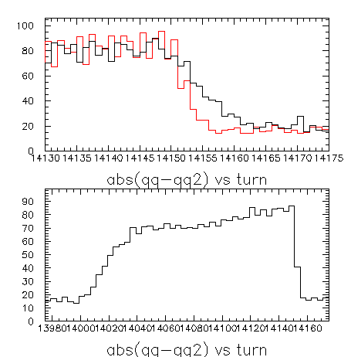

So I declare this a partial success. I will have to check with Eliana to see whether the horizontal decoherence time makes sense here. Also, it would be interesting to try to reduce the tune spread and look to see how things differ.

2008-07-11
((246.1 - 110.7) + ((207.756 - 170.095) / 0.29979)) / 18.8 = 13.884
I see that horizontal kicker cable is (246.1-110.7) ns longer than vertical, and is (207.756-170.095) m upstream of vertical. So horizontal kick should be emitted by damper board 13.9 RF ticks before vertical kick. In fact, it is (after empirical optimization) emitted 14 buckets before vertical kick. Neat!
+++ collection of random facts written down after re-reading my 2006 notes on this project +++
HOR_DAMP: betax=6.641m, mux=2.441 periods, Dx=2.768m, s=170.095m
cable length 246.1ns
VER_DAMP: betay=20.960m, muy=2.957 periods, alpha_y=0.126, s=207.756m
cable length 110.7ns
PICK_UP: betax=6.417m, mux=2.980 periods, alpha_x=-0.290, Dx=2.336m
betay=20.757m, muy=2.965 periods, alpha_y=0.077, s=208.756m
amp input to vertical kicker fanback ~ 318ns
=> amp input to beam ~ 205ns
Qx=6.720, Qy=6.779
so delta mu_y (PU to VD) = 6.712, sine = -0.97
L=474m
gamma(400 MeV)=1.43
gamma(8 GeV)=9.53
gammaT=5.47
hf0 = 38.0 MHz, 52.3 MHz, 52.8 MHz at injection, transition, extraction
Wildman's amplifier (AR 500A100) is flat to +/- 10 degrees from 10 kHz to >100 MHz; good for 500 watts; gain ~ 57 dB (max)
2005-08-01 plan was
1. show that damper board can handle frequency sweep
2. acquire data up the ramp
3. repeat #2 with reduced tune spread to see instability growth rate
4. implement variable delay up the ramp, such that we can apply a kick that follows a given bunch up the ramp
5. show that you can remove one bunch by anti-damping
seeing the notch on the beam on signal vs. turn vs. bucket is nice
I committed booster_dampers on 2006-08-05, with changes as of 2006-02-24;
previous changes had been 2006-02-21.
Quartus 4.1 to avoid SHARC woes.
I can run vmware player (free) on whitespace. Can connect to it with VNC.
Run Quartus 4.1, compile damper project.
P = V**2(rms)/R. 500W into 50 ohms => Vrms = 158V.
( c, s \\ -s+g, c) (y \\ theta) = ( cy + s theta \\ c theta + (g-s) y)
=>
y(N+1) = c y(N) + s theta(N)
theta(N+1) = c theta(N) + (g-s) y(N)
cos(2 pi nu) = <y(N) y(N-1)> / <y(N)**2>
ytwiddle = y/sqrt(beta)
thetatwiddle = sqrt(beta)*y' + (alpha/sqrt(beta))*y
2006-08-07
my "simulation" uses feedback coefs for 3 turns =
(gain/d)*(sin(phi), cos(phi), -sin(phi)-cos(phi))
where phi=0.67*2*pi
100% gain ~ 10-15 turns growth (doubling time); phz=22 maximizes effect
I think transition is at turn ~ 10000. Should be 9500 turns after injection (and f=52.21 MHz) using my program booster_gen_freq_curve.py
back in Sep 2006, damper T1/2 ~ 10-15 turns, while decoherence T1/2 ~ 220 turns, at turn ~ 16000
frequency essentially sweeps from 52.3 to 52.8 MHz above transition: 52.2 to 52.8 MHz in 16 ms.
injection occurs at damper turn ~ 900, so 10400 is where damper should see transition. 17ms after injection.
--- ---
2008-07-15
Bill Ashmanskas, Nathan Eddy
We installed the spare Recycler damper (100 watt) amplifier to drive one plate of the Booster vertical damper. We still have both (500 watt) amplifiers from the MI driving the two plates of the Booster horizontal damper. I had to adjust the kick timing, because the 100W and 500W amplifiers have different delays. Jim Crisp measured the 100W amplifier's delay to be 22.2 ns. I had a crude guess that the delay of the 500W amplifier was 90-100 ns, based on adding up propagation delays measured in 2006. But after adjusting the timing with the scope in the usual way (set D4YFIR:=0x777, D4YPHA:=0, etc.), I found that I needed a 1.5 bucket adjustment, not the 4 bucket adjustment I originally guessed. So it appears that the delay of the 500W amplifier is about 50 ns. This should be confirmed at some point with a direct measurement.
The vertical damper now works, with the 100W amplifier! Damping time appears to be about 9 turns.

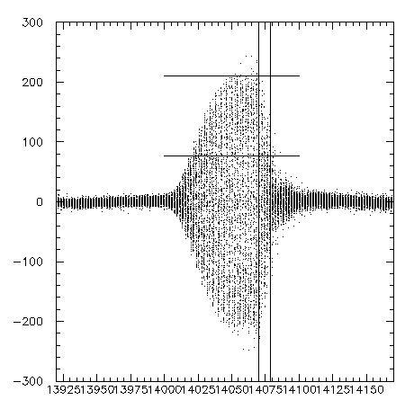graph29.png
The two vertical bars are 9 turns apart; the two horizontal bars are a factor of 2.71828 apart.

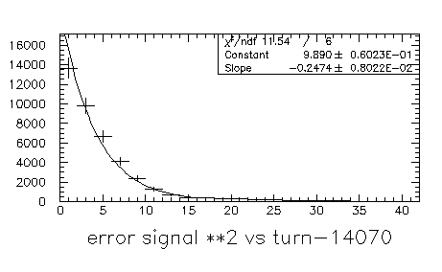graph30.png
Fitting an exponential to error**2 gives a decay time of about 4 turns, which implies about 8 turns for rms error signal.
Again, this is vertical plane, one plate, 100W amplifier.
Bill Pellico increased longitudinal quadrupole damper gain and decreased horizontal chromaticity for us on the $17 cycles. (See today's Booster logbook for the details of what was adjusted in the Booster.) We saw that the damper is really able to damp instabilities!!! This is fantastic!!

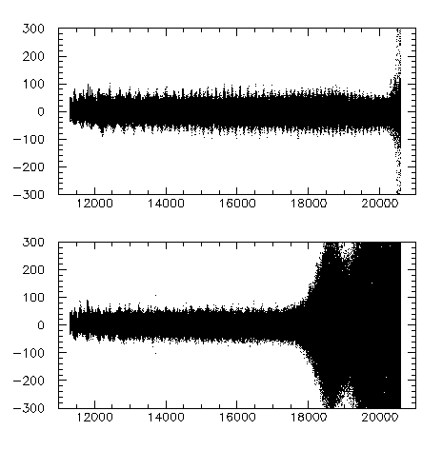

In the above graph, damper is ON in the top half and OFF in the bottom half. What is graphed is the horizontal error signal vs. turn.

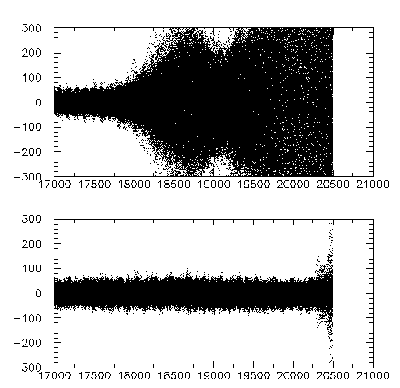

Here is a close-up, showing just the end of the cycle; otherwise same as previous graph. I do not understand why the damper is not able to suppress the activity at the very end of the cycle (turn 20300 or so).

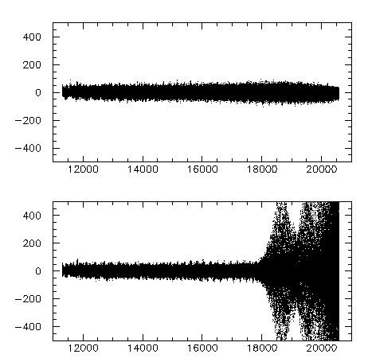

Here is another pair of pulses (damper ON for top and OFF for bottom), with expanded scale.

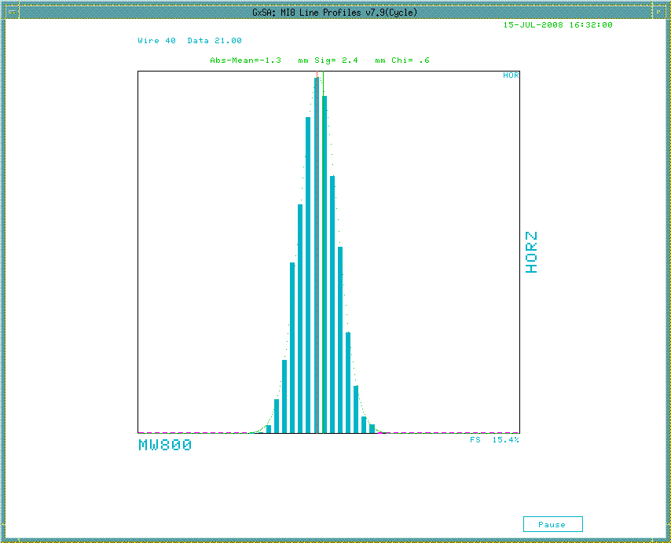

Dampers ON for the above multiwire profile

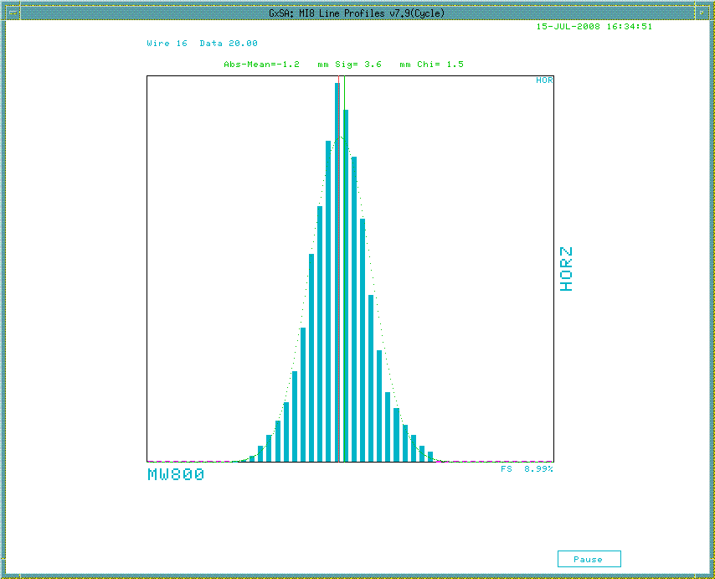

Dampers OFF for the above multiwire profile.

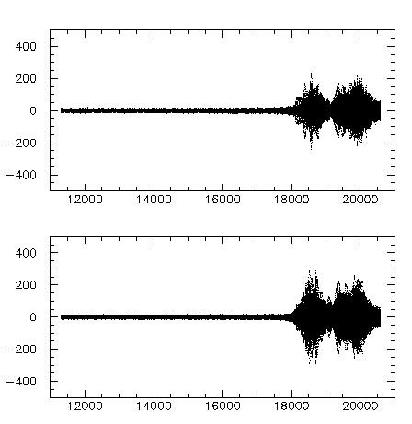

This may be worth investigating further. When the X damper is OFF, I can see the blowup on the vertical pickup too.

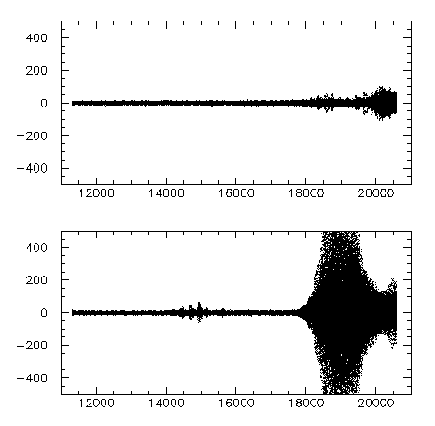

The above graph is vertical error signal vs turn. In both cases, horizontal damper is OFF, but vertical damper is ON for top half and OFF for bottom half. So vertical damper can damp out what spills over into V plane from H instability shown earlier. I see this ON/OFF difference reproducibly on several OFF and several ON pulses. But if the horizontal damper is on, the vertical blowup doesn't occur.
I'm going to call it a day. I think the most urgent thing to do tomorrow is to add some devices that can be graphed via ACNET Fast Time Plot to show the summed absolute value of the error signal, summed over bunches for some number of turns (1 turn? 256 turns?). (There are 600-900 revolutions in a 720 Hz tick.) Then the same for the kick signal. Nathan suggests that we should also put out the maximum value seen for any bucket within the interval, so that saturation can be detected.
I'd also like to put a 20dB coupler onto each DAC output so that we can run a copy of each amplifier input into the oscilloscope.

